July 2007 Enjoy your Summer Volume 21, Number 3
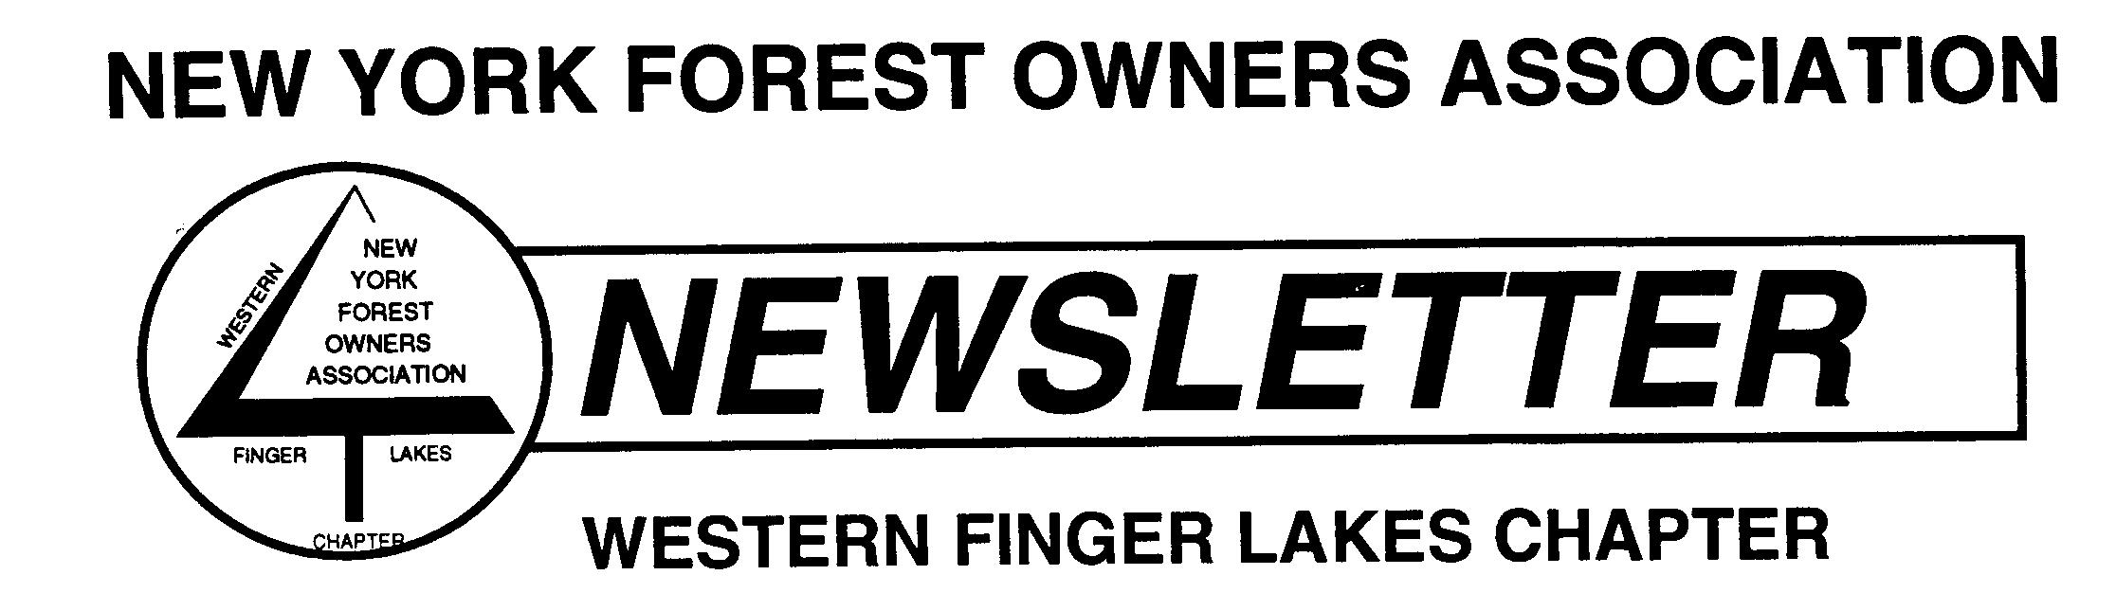

WFL Chapter Meetings and Coming Events

- WFL Chapter Board of Directors Meeting - The next WFL Chapter Board of Directors meeting will be held August 29th and will start at 7:00 pm. The meeting will be held at the DEC A-frame in Avon at 6274 East Avon-Lima Road (Routes 5 & 20 – a few miles east of I-390). Everyone is welcome to attend.
----------------------------------
Highlights of Spring Activities and Programs

The Life and Times of Charlie Chestnut: Our guest speaker Herb Darling, who is President of the New York State Chapter of the American Chestnut Foundation, presented an interesting program titled “The Life and Times of Charlie Chestnut”. The program was held March 14th at our general meeting, at the Monroe County Cooperative Extension Building in Rochester, 21 people were in attendance.
-----------------------------------------------------------------------------------------------------------------------------------------------

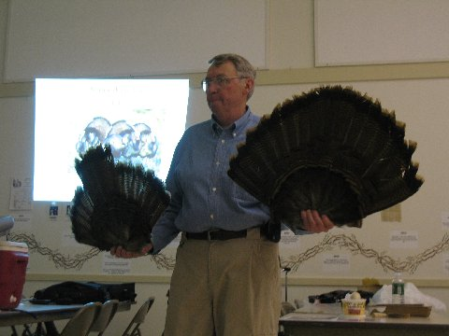
Wild Turkey Biology: Larry Becker, NYFOA member and President of the NYS Chapter of the National Wild Turkey Federation (NWTF), presented a program titled Wild Turkey Biology, Life Cycle, and Habitat Needs on May 9th at the general meeting in Honeoye, 21 people attended. The goal of the presentation was to give the audience a brief overview about wild turkeys, and the NWTF’s private landowner conservation recognition program. As a volunteer member of the NWTF Larry is currently the New York State Chapter President, Chairman of the NYS Chapter Wild Turkey Woodlands Committee and a member of the NWTF’s Habitat Pro Staff. He is also a NYFOA member and a certified Master Forest Owner volunteer through the Cornell University Cooperative Extension program.
-----------------------------------------------------------------------------------------------------------------------------------------------

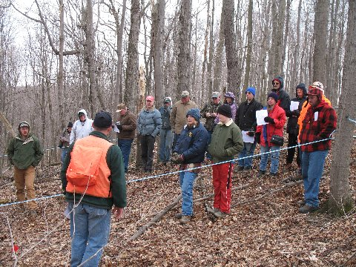
Sugarbush Hollow Woods Walk: The 5th Annual Woods Walk at Sugarbush Hollow, in East Springwater N.Y, was held on April 14th. There were 38 people in attendance. Once again there was a lot to see. Cornell has set up an experiment comparing a control plot with a plot that was thinned 20% and another plot that was thinned 40%. The results of 5 years after a commercial harvest and a post harvest TSI activities on a sugar maple, black cherry and oak forest. Various forest speakers were on hand to discuss their areas of expertise. Pancakes were served for lunch with fresh syrup. We want to thank Chuck Winship for hosting the woods walk and look forward to next year’s visit.

*We want to thank the organizers and speakers for providing our members and visitors with these excellent programs.*

Summer Woodswalk – Krebs Property
August 25th at 10:00 am

The Western Finger Lakes Chapter of NYFOA is sponsoring a Woodswalk on August, 25 2007. This joint event with the Finger Lakes Land Trust will be held at the Krebs property near Springwater. The property is protected by a conservation easement held by the Land Trust, and is managed for timber production and wildlife habitat. This woodswalk will showcase how forest management and conservation easements can complement one another to protect land from development while allowing owners to pursue their objectives for the property.

Betsy Landre of the Finger Lakes Land Trust will be on hand to discuss the conservation easement, the benefits it confers and the obligations it imposes on current and future owners of the property. She will also talk about recent changes in tax laws that make conservation easements more attractive to landowners, and whether and how landowners can pursue easements for their own property.

Billy Morris is a forester who has worked with the Krebs family to manage the property for many years. He will discuss the Krebs’ stewardship plan and show us a recent timber harvest on the property. He will also talk about how land management activities are influenced by the conservation easement.

This event if free and open to the public.

For more details, contact Mike Seager at (585) 414 6511 or seager_michael@yahoo.com, or
Dick Starr at (585) 377 4849 or Pockaa@aol.com.

Date: 25 August, 2007
Time: 10:00 am
Location: Meet at the intersection of Peglow and Dutch Hollow Roads in the town of Springwater.
Directions: From the village of Springwater, go north on State Route 15A. Take the first right north of the village, onto Wheaton Hill Road. Follow Wheaton Hill Road to its end at Wetmore Road. Turn left on Wetmore Road, then take a quick right onto Tabor Corners Road. Bear left onto Dutch Hollow Road, then the next intersection is Peglow Road. The total distance from the village of Springwater is about four miles.

Springwater can be reached from the north by taking Interstate 390 south to exit 9 (Lakeville). Follow state route 256 south to route 20A; take 20A east to Livionia. Follow state route 15 south from Livionia to Springwater.

From the south, take Interstate 390 to exit 3. Take state route 15 north through Wayland and into Springwater.

Announcements

1.) Cornell Launches Forestry Education Internet Seminars for Landowners: Cornell University is launching an on-line forestry seminar series to woodlot and forest owners. The nation’s first direct and interactive link to experts on private forest land issues was broadcasted May 16 on the topic, “Key Forestry Concepts and Principles.” Landowners are encouraged to sign up for the innovative series at www.ForestConnect.info. “We want to provide unbiased and research-based information on forests and woodlot management directly and instantly to forest owners and others who are often too busy to attend workshops and forest tours,” said Peter Smallidge, state extension forester in Cornell’s department of natural resources. The ForestConnect 2007 Forestry Internet Seminar Series will provide interactive seminars via the web that teach participants strategies about enjoying and utilizing their property. The one-hour monthly seminars, which are being offered by Cornell Cooperative Extension, will cover a single, timely topic and allow for questions and answers with the presenter. Forest owners and enthusiasts with a broad variety of interests will be served by this initiative. The ForestConnect 2007 Internet Seminar Series will occur on the third Wednesday of each month from noon to 1:00 PM, with a repeat live broadcast the same day from 7:00 to 8:00 PM. The noon-hour broadcast will be saved for subsequent viewing on the ForestConnect website. Participants must pre-register once, without charge, at www.ForestConnect.info. Email notification of internet URL details will be sent to all registrants prior to each session. Future Topics: July 18th: Working With Foresters, August 15th: Timber Sale Arrangement – Payments and Contracts, September 19th: Small-Scale Firewood Production, October 17th: Creating Vernal Pools for Wildlife (tentative), November 21st: Natural Regeneration in Your Hardwood Forest, December 19th: Don’t Degrade Your Woodlot. Presenters are technical experts from the area of forestry and natural resources. The ForestConnect 2007 Internet Seminar Series is designed for forest owners and forest enthusiasts from New York and the Northeast, but will interest most forest owners. Funding is provided through the Cornell University College of Agriculture and Life Sciences, Cornell University Cooperative Extension, and the USDA Renewable Resources Extension Program. For more information, contact Peter Smallidge at pjs23@cornell.edu or 607-592-3640.

2.) New York Forest Owners Association members asked to complete a short member feedback survey. What Issues are Important to New York Forest Owner? In order to help focus on the issues that are most important, members are asked to go “on-line” to complete a brief member opinion survey at www.nyfoa.org. To request a paper copy call 800-836-3566 or email info@nyfoa.org.

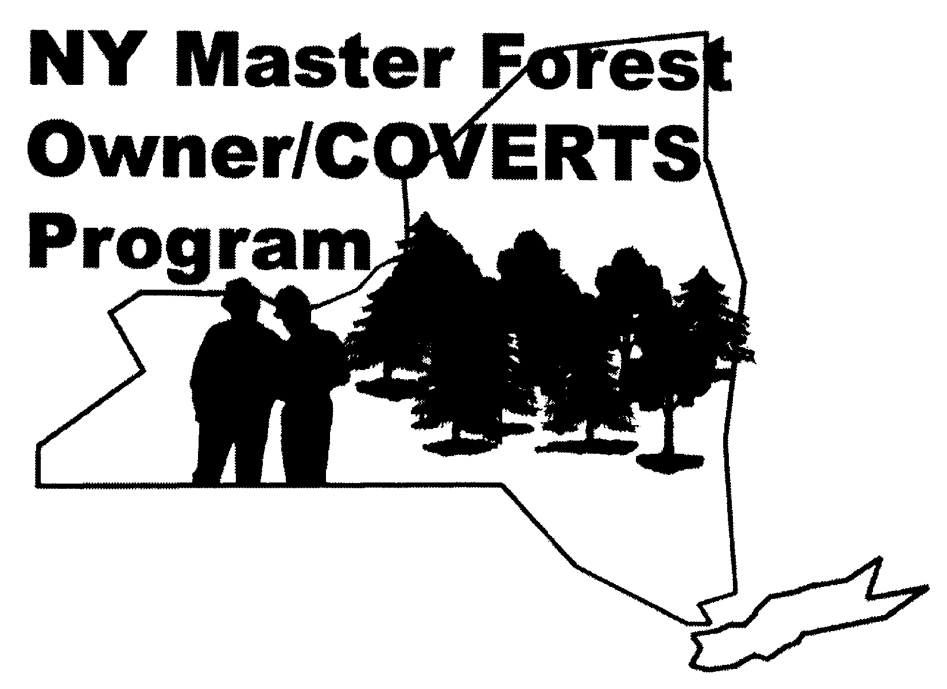
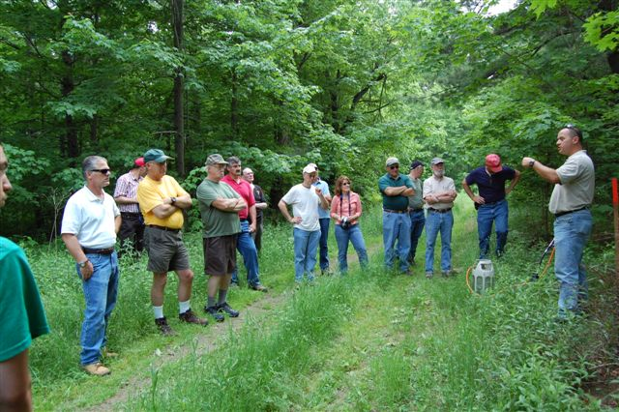
3.) Master Forest Owner Regional Coordinators Appointed: A corps of 12 volunteers are now regional coordinators for the NY Master Forest Owner Volunteer Program. The newly established Master Forest Owner (MFO) Advisory Committee (comprised of NY Forest Owner Association members, Cornell Cooperative Extension Educators, and MFO volunteers) has recruited 12 of the 13 volunteers needed to fill "MFO Regional Coordinators" across the state. The regions generally coincide with the NYFOA Chapter regions. The primary objectives of creating the regional positions are to help improve program communications and administration, and improve coordination of regional activities such as recruitment and promotion of MFO volunteer services. The NY Master Forest Owner Volunteer Program provides private forest owners of NY State with the information and encouragement necessary to manage their forest holdings wisely. Over 135 experienced and highly motivated volunteer MFOs are available statewide; ready to assist neighbor forest owners with the information needed to start managing their forests. All MFOs are graduates of a 4-day training program conducted by Cornell Cooperative Extension. The initial and refresher trainings included practical information on sawtimber and wildlife management, forest economics and forest ecology. Sponsors of the MFO Program are the Robert H. Wentorf Jr. Foundation, USDA Renewable Resources Extension Program, NY Forest Owner Association, NYS Department of Environmental Conservation, and Cornell Cooperative Extension. Forest owners interested in contacting a local MFO volunteer to arrange a visit to their forest can obtain a listing of MFOs by county at the MFO website www.cornellmfo.info or by calling their Cornell Cooperative Extension County Association. Forest owners interested in becoming a MFO volunteer can complete an application form also at that website, or can obtain an application by calling Diana Bryant at 607-255-2115. The 2007 MFO training will take place at Cornell’s Arnot Forest September 19-23. Applications must be received by August 27.

4.) DEC Announces New Website (www.dec.ny.gov): New York State Department of Environmental Conservation (DEC) Commissioner Pete Grannis announced the unveiling of the Department’s new, redesigned website. The greatly improved website went live on May 4, 2007, complete with a new address, www.dec.ny.gov . The new site provides features that make it easier use for visitors to find the information they are looking for, and uses automated content management to handle the Department’s large and growing site with speed and reliability. “This redesign is the product of many months of vigorous effort on the part of the

DEC web team and staff throughout the Department, said Commissioner Grannis. “A key element in the Department’s mission is to raise awareness of the environment and environmental issues in the minds of New Yorker’s. With millions of visitors each year, the website is a powerful tool for accomplishing this mission.” In the ten years since its inception, the site has grown tremendously, and the number of visitors has multiplied each year. Last year, more than 9.2 million new and returning visitors consulted DEC’s website for answers to their environmental questions. In the site’s more than 33,000 files, there is information that is as varied as where to get a sporting license, to when a local hazardous waste site will be cleaned up, to what kind of animals live in New York, to how to help reduce global warming. The website redesign project was carried out in consultation with site users and Department staff, incorporating ideas from a focus group and suggestions received over several years through website feedback and site use records. On the redesigned DEC website, visitors can browse quickly through a topical organization to find the information they want and need. The Department’s website represents a large investment of resources in content development and management. Along with updating the look and feel of the site, this redesign project introduces automated web content management in order to maximize the benefit New Yorker’s will get from this investment. The newly-adopted web content management system will provide “breadcrumb” navigation, automatic PDF creation, printer-friendly page versions and other features important to users. Automated content creation and editing will make it easier for staff to keep content up to date, and provide more reliable management of the large and growing site.

5.) Society of American Foresters (SAF) Releases 'The State of America's Forests' Report: The Society of American Foresters has published a comprehensive, definitive report of facts and data about U.S. forestlands. This report is available online at www.safnet.org and is a free resource to the public. “We believe one of our responsibilities as a professional society is to make credible forestry information available to the public in an understandable and readable format,” says Michael Goergen, Executive Vice-President of the Society of American Foresters. “We all have a responsibility for the future of our forests.” The report states that the United States ranks fourth on the list of most forest-rich countries, following the Russian Federation, Brazil and Canada, with eight percent of the world’s primary forests. * The number of acres of forestland in the United States has remained essentially the same during the past century. * An estimated 25 percent of U.S. private forestland is managed in accordance with one of the three major forest certification programs in the U.S. (the Sustainable Forestry Initiative, the Forest Stewardship Council and the American Tree Farm System), and conservation initiatives on private land, such as easements, are becoming increasingly common. *On average, 11 percent of the world’s forestland benefits from some type of conservation effort. In the United States, 20 percent is protected by conservation initiatives. *Assessments of biodiversity on the nation’s forests have found that the annual rate at which species are listed as threatened or endangered has declined five-fold. *The 68-page report uses more than 50 sources of facts and figures from a broad range of sources, including the U.S. Department of Agriculture Forest Service and the U.S. Department of Interior Fish and Wildlife Service. The report was also peer-reviewed by researchers from non-government organizations and federal agencies. (Reference: http://forestry.nacdnet.org/forestrynotes/May07/oak.htm)

6.) Forests Farm Bill Survey: Poll results released on March 28th show that American voters are concerned about the consequences of forest loss and support Federal action and conservation programs to help keep privately-owned forest lands intact for future generations. The newly-launched Forests in the Farm Bill Coalition, the poll sponsor, urges Congress to take immediate action through the Farm Bill to protect forest lands and the significant economic and environmental benefits forests provide. The poll showed that sixty percent of the public mistakenly believes that the Federal government owns and manages most of our nation’s forests. But in fact, two-thirds of all U.S. forests are privately-owned, and most acres are held in small tracts by families and individuals. When people learned that families, not the government, own most forests, 9 in 10 voters agreed that more needs to be done to help conserve forests. More than three in four respondents polled said they would support a Farm Bill with a significant amount of funding for the conservation and restoration of privately-owned forests.

- 95% said they would support providing technical advice to forestland owners to help them better manage and conserve forests.
- 65% said they would support providing financial assistance to private woodland owners who depend on forest for income to help them conserve their forest lands.
- 80% of those polled said they support offering incentives for forestland owners to conserve forest on their property.

Results are drawn from a national telephone poll of 1,100 adults sponsored by the Forests in the Farm Bill Coalition, conducted in February 2007 by the firms of Fairbank, Maslin, Maullin and Associates and Public Opinion Strategies. Historically, the Farm Bill has served as the primary vehicle for Federal rural conservation programs on private lands. The Farm Bill has the potential to help private forestland owners meet their needs, while also sustaining the economic, ecological and social values that their lands provide for the public. The Forests in the Farm Bill Coalition was formed to assure that private forests are viewed as a vital part of the rural landscape and economy, to improve the effectiveness of programs for private forest conservation and management, and increase resources for these programs. Among the coalition’s 33 members are major environmental, conservation and business groups as well as organizations representing family forest owners, sportsmen and sportswomen, forestry professionals and academics.
(Reference: http://forestry.nacdnet.org/forestrynotes/Apr07/Sims.htm)

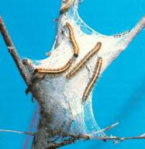
7.) DEC Commissioner Advises Property Owners to Watch for Spring Caterpillar Pest, Provides Guidance on How to Avoid and Control Defoliators: New York State Department of Environmental Conservation (DEC) Commissioner Pete Grannis alerted residents to be on the lookout for common spring insect defoliators and provided guidance on how to control these pests. Overall populations of forest tent caterpillars, eastern tent caterpillars, gypsy moth caterpillars, saddle prominent caterpillars and a group of caterpillars commonly called inch-worms will be high again this year, Commissioner Grannis said. Most trees will survive an initial defoliation by these caterpillar pests in the early growing season and will usually re-foliate in the early summer when they are gone. Defoliation can weaken trees making them more susceptible to other potential stressors such as drought, disease or other insects. Therefore, consecutive years of defoliation can kill a tree. Fall surveys conducted by the DEC Forest Health crews have shown that there are large populations of these defoliators in several counties, most of which had caterpillar problems last year. Because these caterpillars are somewhat mobile, the damage can easily spread past these counties. Effective mechanical treatment options for controlling infestation on individual trees include hand removal of egg masses, inhabited caterpillar tents and pupa, and installation of sticky tree wraps on trunks to capture caterpillars as they move up and down trees. If you choose to use pesticides to control defoliator infestations, these treatments should be used wisely and according to label instructions. DEC recommends using a New York State registered pesticide business that employs certified pesticide applicators. Some pesticides used to control harmful insects are contact poisons and could endanger a variety of beneficial insects, such as honeybees, as well as nesting birds and other animals. Spraying is not effective against pupae or egg masses, and is less effective once caterpillars reach one inch in length. To find a list of registered pesticide businesses that can perform pesticide applications on your property, visit DEC’s website at www.dec.ny.gov , and follow the link for Pesticides under the Chemical & Pollution Control section on the homepage. All treatments, mechanical and chemical, are most effective when applied while the caterpillars less than an inch long. Generally, treatments are less effective when leaf loss is noticeable. Do not attempt to burn caterpillars and their tents while they are on trees. This is hazardous to the health of the tree and can be very dangerous. Contact your regional DEC office or county Cornell Cooperative Extension office (www.cce.cornell.edu) for additional information and management options. For more details regarding spring defoliators, including areas that can be affected, visit DEC’s website at www.dec.ny.gov , and follow the link to Insects & Other Species, under the Animal, Plants, Aquatic Life section on the homepage.

Calendar of Other Events

- July 14 - New York Nut Growers Association Summer Meeting: The New York Nut Growers Association will hold its summer meeting on Saturday, July 14 in Trumansburg and Dryden. In the morning we will visit the Carpathian walnut plantings on John Wertis' BWW Farm, 8144 Searsburg Road, in Trumansburg, and do some fence building to protect against deer damage. In the wooded section of the farm, an agroforestry staff member from Cornell will demonstrate mushroom inoculation of logs. Select your lunch at the Hazel Nut Cafe: mild goat curry, hazelnut broiled trout, or vegetarian pasta. In the afternoon Janet Hawkes, of RPM Ecosystems, will make a presentation about their tree propagation system in the Trumansburg Village Hall (across from the café). Then we will drive to Dryden, about a half hour away, to visit RPM's greenhouses and field plots. Registration includes a light breakfast and lunch -- all for $15. Please mail a check, made out to "NYNGA," to Tom Potts, NYNGA Treas., 26 Willets Ave., Belmont, NY 14813. Drop-ins are welcome, too. Questions &/or directions, call Tom at (585) 268 - 5588.

- Friday July 20 and Sat. July 21 -2007 MFO Arnot Forest Refresher Workshop, $15 registration fee includes all food and overnight expenses, Arnot Forest Lodge, 611 Co. Rt. 13, Van Etten, NY. Directions and more info about the Arnot at http://www.dnr.cornell.edu/arnot/

Friday (optional, please let them know if you will be attending and staying over at the Arnot).
5:00 p.m Registration and chance to mingle
6:00 DINNER
7:00 The role of forests in carbon sequestration, the selling of carbon credits and ethanol production from grasses and wood chips – speaker to be arranged
8:00 Forestry in Argentina – Brett Chedzoy, Schuyler County CCE Educator
9:00 Snacks and beverages

Saturday
8:00 BREAKFAST
9:00 MFO volunteers report activities. MFO Regional Coordinators and NYFOA updates Jerry Michael ’95 MFO
10:00 MFO program report, Biodiversity in the NY’s Southern Tier -- Gary
11:00 Tour of the Arnot Summer Intern Projects
- Assessing tap hole closure in sugar bush -- Steve Zelno
12:00 LUNCH (subs ordered out)
12:45 Intern Project Tour continued: 1) Grassland management for songbirds -- Meaghan Black, 2) Forest management for sawtimber production and impact on salamanders and reptiles -- John Koltz. 3) Forest vegetation management: Controlling beech regeneration via selective stump treatment using glyphosate and control of barberry, striped maple and autumn olive using propane torch -- Mike Wine. 4) Agroforestry: mushroom production-- Ari Reynolds
4:30 Adjourn

- August 7, 8 & 9 - Empire Farm Days: Over 600 exhibitors representing the latest technologies, products and services exhibited at Empire Farm Days in '06. This year is expected to be even bigger with special events, seminars and presentations. From Dairy to Timber and all AG in between. For more information call 877-697-7837 or visit www.empirefarmdays.com.

- Sept 22 and 23 - National Hunting and Fishing Days: Sept 22 and 23 - 10am to 4pm, NYSDEC 6274 East Avon-Lima Road, Avon, NY. Come and celebrate National Hunting and Fishing Days in late September at the DEC Regional office in Avon. Events include skeet shooting, hunting dog demonstrations, fishing clinics and more. Hundreds of vendors and DEC program information will also be on site. For more information, call the DEC at 585-226-2466.

- September 23, 24, 25 : 2007 New York State - Maple Tour, Tour Center – Farmers' Museum, 5775 State Route 80, Cooperstown, NY 13326 - On behalf of the Otsego County and New York State Maple Producers Associations, we are pleased to invite you to attend the 2007 New York State Maple Tour. This year's tour will be centered in Central New York's Otsego County. Participants will be able to tour the beautiful countryside made famous by James Fenimore Cooper and visit seven local sugar operations and a Cider Mill. The Tour will be centered at the Farmers' Museum in Cooperstown. While visiting Cooperstown you may want to see some of the many other attractions including: the Farmers' Museum areas not utilized by the Maple Tour, the Baseball hall of Fame (your Maple Tour name tag will get you a discount), Fenimore Art Museum, and much more that can be previewed at www.visitcooperstown.com. The tour registration will start at 2:00PM on Sunday afternoon with the trade show opening at 3:30 PM and a social from 4:00 PM to 8:00PM at the Farmer's Museum. For many of you this will be an opportunity to renew old acquaintances and greet newcomers. For producers just getting started, this will provide some information and ideas you can take home with you. The Otsego County Maple Producers have worked since last autumn to coordinate a tour that will be enjoyed by all.

Sunday, September 23
• 2:00 to 8:00 PM Registration
• 3:30 to 8:00 PM Trade Show
• 4:00 to 8:00 PM Social in the Trade Show
Monday, September 24
• 6:30-8:00 Continental Breakfast -Museum
• 8:00 AM Buses Depart
• 6:00 PM Reception and Trade Show
• 7:00 PM Banquet at the Farmers' Museum
Tuesday, September 25
• 6:30-8:00 Continental Breakfast -Museum
• 7:30 to 8:00 AM Buses Depart

Tour Stops: Farmers' Museum, Maple Hill Farm Enterprises, LLC, Dismal Inn Maple, Stickey Ritchey's Maple, Smokey Hollow Maple Products, Stannard's Maple Farm, Stone House Farm, Breezie Maples Farm, and Fly Creek Cider Mill. Registration Form - is available at http://maple.dnr.cornell.edu. Or call 607-547-2536. Registration must be received by Friday, September 1, 2007

- Oct. 9-10 - SUNY-ESF Host Conference on Forest Biorefinery, Forest bio-refinery – Establishing a path forward, Tuesday, Oct. 9 - Wednesday, Oct. 10, 2007. (Syracuse, N.Y.) – “The future of renewable energy resources is happening right here and right now,” said Dr. Cornelius B. Murphy, Jr., president of the SUNY College of Environmental Science and Forestry, announcing the 2007 Forest Biorefinery conference to be held Oct. 9-10 at the Holiday Inn Syracuse/Liverpool. “New York’s wood-based biorefinery project will not only produce renewable energy but create economic vitality for the forest products industry and revitalize rural agriculture with the development of a new cash bio-energy crop by putting marginal farmland back into production.” More than 200 ethanol producers, state and federal policymakers, forest owners, biomass producers, energy producers, wood scientists and harvesters, agricultural experts, economists and investors are expected to attend. For conference agenda and additional information visit the web at http://www.esf.edu/outreach/pd/2007/Biorefinery/speakers.htm, or contact Maureen Wakefield, Continuing Education Coordinator, SUNY College of Environmental Science and Forestry, 219 Bray Hall, Syracuse, NY 13210, phone: 315-470-6888, fax: 315-470-6890, email: mwakefield@esf.edu

Some Interesting and Maybe Helpful Websites
- Treelink - This site was created to provide information, research, and networking for people working in urban and community forestry. For the researcher, the arborist, the community group leader, the volunteer - our purpose is to inform, educate, and inspire. Mission Statement: To improve urban and community forests by providing Internet-based information, tools and inspiration. http://www.treelink.org/

- American Farmland Trust - Founded in 1980 by a group of farmers and conservationists concerned about the rapid loss of the nation's farmland to development, American Farmland Trust (AFT) is a nonprofit membership organization dedicated to protecting our nation's strategic agricultural resources. http://www.farmland.org/.

- New York Center for Agricultural Medicine and Health - The New York Center for Agricultural Medicine and Health was established by the New York State Legislature in 1988. Recognizing the unacceptably high rates of occupational injury and illness in New York's largest industry, the legislature has charged NYCAMH to provide: (1) Research into the causes and prevention of agricultural injury and illness, (2) Education and prevention activities within the farm community, (3) Education of professionals serving the farm community, (4) Clinical help for farm-related health problems. http://www.nycamh.com

- Natural Gas Exploration and Leasing - Provides comprehensive inventory of information concerning natural gas exploration and leasing to assist private landowners in making better decisions. (Penn State Cooperative Extension) http://naturalgaslease.pbwiki.com/

-------------------------------------------------------------

Estate Planning—Maximize the Transfer of Assets To Your Heirs

Feature Release, Release No. MFO-03-07, (May 8, 2007) USDA Forest Service, Northeastern Area State and Private Forestry, http://www.na.fs.fed.us/nanews/nastories/estateplan.html

You have title to land for one of several reasons—you may have purchased it, inherited it, or married someone that owned land. You have cared for your land and improved its productivity, or maybe you own several acres that simply provide a refuge for relaxation. Regardless of how much acreage you own or your purpose for owning it, you want to protect what is yours and pass it on to future generations.

Although you may have devoted time and resources to managing your land, you may have given little attention to the best way to transfer this land to your heirs. Transferring your land and other assets to others requires some work on your part to ensure that they go where you want. But careful planning can create an orderly process that will distribute your assets in the shortest amount of time and ensure that more of your assets go to those you choose rather than someone else.

Estate Planning - The estate planning process begins with thinking about what you have and where you want it to go. Talk with people to whom you want to transfer your assets to get an idea of their thoughts. “Developing an estate plan is important for establishing who gets your stuff when you die. Without a plan, probate procedures will determine where your stuff goes,” said University of Vermont Extension Forest Resource Specialist Thom McEvoy.

Your estate covers all of your assets. In addition to land, other assets include insurance policies, annuities, stock portfolios, bank accounts, bonds, CDs, and collectables, to name just a few. The importance of establishing an estate plan increases as the value and complexity of your assets increase.

After thinking about how you want to distribute your possessions, the next step is to find a qualified estate planner to develop an estate plan. A qualified planner may have a title such as Certified Financial Planner (CFP). Contact the Estate Planning Council to find the nearest CFP. A CFP will advise you regarding what legal forms would best fit your individual estate planning needs. They may also give you information about other steps to take to pay for the expenses your heirs may incur. In most cases, a CFP will also be able to recommend an attorney that specializes in preparing the two legal documents used for estate planning—wills and trusts.

Wills and trusts direct how you want your estate distributed. Both have distinct advantages and disadvantages to consider when deciding which best suits your situation. Neither a will nor a trust can eliminate Federal or State estate taxes, but they can reduce the Federal estate tax and provide a means to pay the taxes incurred if they are set up properly.

If the land you own is near an area where development is occurring, you may want to have your land assessed for agricultural use every few years to document the value of the property. The IRS calculates estate taxes based on property values, which are determined by examining recent land sales in the vicinity of your land. If your property is adjacent to development, its assessed value and resulting estate taxes may be higher because of its development potential. If documentation exists that you regularly have the land assessed for agricultural use, the IRS will be more likely to make estate tax calculations using agricultural valuations rather than development valuations.

Wills - Wills are the most commonly used legal document to transfer an estate. “Wills are an expression of a person’s desires. They state who it is that you wish to receive assets,” said McEvoy. They are relatively inexpensive and generally cost several hundred dollars to prepare. However, all wills must go through probate and are available for public scrutiny. As part of the probate proceedings, the law requires that a notice of your death be published in newspapers. This means that anyone can read the notice and request to see the contents of the will. They can then make a claim by contesting the will, which can tie up the distribution of assets for years. In addition, a will does not have any method to alleviate the Federal estate tax burden.

While the cost of setting up a will is reasonable, the costs of executing a will can be considerable. The process of probating a will can include court fees, attorney fees, and executor fees. The process can also take anywhere from 9 months to 2 years to complete without litigation. During the probate period, no assets belong to your heirs. Your heirs may, however, have to file (and pay) income taxes for the estate in addition to estate taxes due during the probate period. Probate costs can be between 5 percent and 7 percent of the value of an estate.

Trusts - A trust is a legal document that creates a mechanism for you to transfer your assets to one or more beneficiaries. You act as guardian, or trustee, of the trust. A trust does not expire when you die; a successor trustee is appointed who has the legal authority to sign over the contents of the trust to the designated beneficiary.

The two most common types of trusts are the revocable or living trust, and the marital or A-B trust. Trusts avoid time delays by transferring assets out of your name into the name of the trust. A trust is beneficial if a sizable portion of your estate consists of real estate. Trusts can reduce estate and gift taxes and efficiently distribute assets held within the trust without the cost, delay, and publicity of probate. Some trusts may also offer greater asset protection from creditors and lawsuits.

Trusts require more work to set up properly than wills and cost several thousand dollars to prepare. A trust is also a taxable entity, and income derived from assets in the trust are taxed at the highest rate. A trust is not recommended if you are in the process of applying for Medicaid or if there is a strong possibility due to age or financial conditions you may need to apply for Medicaid in the next few years.

Maintaining Your Estate Plan: After you have developed an estate plan and have a will or trust drawn up, review it every year to make sure it is kept up to date. The will or trust should only require minor revisions unless you have major life changes or there is a shift in the tax code.

Additional Information - Gifting and additional life insurance are two other strategies you can use to transfer your estate’s assets or provide money to cover estate taxes.

You can gift land to your heirs. Deeding your land in pieces to someone else each year is a straightforward, but relatively costly, way to do this. You will need a qualified attorney to annually walk you through this process. You can give up to $12,000 in tax-free gifts every year; it may take several years to gift all your land depending on its fair market value and the number of recipients. Using a trust to gift land is more complicated. Gifting is not a recommended strategy if it would put your financial security at risk.

Purchasing additional insurance provides extra cash for your heirs to pay estate taxes and other costs. If you use a trust, the trust owns the policy and is the beneficiary. If you are not using a trust, the additional insurance is not subject to probate and will go directly to beneficiaries listed on the insurance policy.

More indepth information can be found in Estate Planning Opportunities and Strategies for Private Forest Landowners. This publication is available online at the National Timber Tax Web site at http://www.timbertax.org/estate/estate.asp.

The information presented here deals with the basics of estate planning to provide wealth protection and efficiently distribute your wealth to your immediate heirs. There are other methods available that establish a lasting protection for your land for future generations, including establishing an S-corporation, limited liability company (LLC), and family forest partnership. These methods are beyond the scope of the material presented here and will be addressed in another document.

Side Bar
Estate Tax Exemption—The estate tax exemption is a tax schedule passed by Congress. If the total value of your estate assets is less than the exemption amount, no estate tax is charged to your heirs. The estate tax rate is 46% of the value of all assets above the estate tax exemption limit. For example, if you die in 2009 and your estate is valued at $4.612 million, the estate tax exemption will be $3.5 million and your heirs will owe a 46% estate tax on $1.112 million, or $511,520.

Estate Tax Exemption
Year | Estate Tax Exemption
2006 – 2008 | $2 million
2009 | $3.5 million
2010 | No Federal estate tax
2011 | $1 million

In addition, many States also impose a tax of some type. The tax goes by different names depending on the State, and the specifics on how the tax is calculated vary. It is important to discuss State estate tax requirements with a qualified individual to fully understand the circumstances your heirs could face.
Gift Tax Exemption—You are allowed to give up to $12,000 in tax-free gifts every year to as many people as you wish. Your spouse may also do the same, which increases the value of tax-free gifts that couples can give to $24,000 annually. There is a maximum lifetime gift tax exemption of $1 million.
Estate Planning Options for Family Forests – The US Forest Service Northeast Area State and Private Forestry (NA) worked with AARP to publish the story on the importance of family discussions in preventing fragmentation and parcelization when land transfers from one generation to the next. As part of that article-related effort, a team of NA staff created a web site that features a broad array of Estate Planning resources. The Estate Planning information can be found at http://www.na.fs.fed.us/stewardship/estate/estate.shtml.

-------------------------------------------------------------
Welcome New Members

James & Jennifer Beardsley | Red Creek |  | Kathryn Franz &  Vance O'Donnell | Rochester
Gerrett Geartz | Honeoye |  | Ted Retzlaff | Rochester
Timothy Grooms | Pavilion |  | James L. Richards | Lockport
Craig Knobel | Honeoye |  | William R. Shaw | Trumansburg
Chris Nally | West Bloomfield |  | Jeff Sitter | Geneva
Charles & Sarah Stackhouse | Bluff Point |  | Craig Stephens | Naples
Bruce Vande | Webster

Tree Tubes available from WFL

Contact Ron Reitz at 585-367-2847

Tree Tube Description |  | Member Price | Non-member Price
4’ without stakes |  | $3.00 | $3.50
5’ without stakes |  | $3.50 | $4.00
4’ with stakes |  | $3.50 | $4.00
5’ with stakes |  | $4.00 | $4.50
Also available – slightly used 4’ without stakes @ $1.75 apiece.

-------------------------------------------------------------

Closing Comments

Please consider donating your time and talents in assisting the WFL Chapter with its many activities. Any assistance you could give to the Chapter would be greatly appreciated.
Some current vacant positions and/or openings include:

*Vice Chair
*Outdoor Activities Coordinator
*Publicity Director
*Membership Director

Final Note: If you have a news item, announcements, stories, or any other information you would like to add to the Chapter Newsletter please send them to Lake Plains RC&D, 446 West Ave, Albion, NY 14411. The next Newsletter will be out mid-October, so I would need the information by or before October 1st. If you wish to submit a letter for entry into the newsletter, please send it to the Chairperson for consideration by the Board of Directors.

The WFL Chapter newsletter is created with support from the Lake Plains RC&D. The RC&D program is sponsored by the USDA NRCS. All programs and assistance of the RC&D Council are offered on a non-discriminatory basis, without regard to race, color, national origin, sex, sexual orientation, age, marital or family status, disability or political beliefs."
“The Best Time to Plant a Tree”

The Best Time to Plant a Tree was Thirty Years Ago.

The Second Best Time is Today
~ Chinese proverb

NEW YORK FOREST OWNERS ASSOCIATION
PO BOX 541
LIMA, NEW YORK 14485
NONPROFIT
ORGANIZATION
U.S. POSTAGE
PAID
Lima, NY
Permit No. 2

The NEW YORK FOREST OWNERS ASSOCIATION NEWSLETTER is published for members of the Western Finger Lakes Chapter of the New York Forest Owners Association (NYFOA) and is published 4 times per year. NYFOA was founded in 1963 and is organized to encourage the wise management of private woodland resources in New York State by promoting, protecting, representing and serving the interests of woodland owners. The Western Finger Lakes chapter was founded in 1988 and encompasses Genesee, Livingston, Monroe, Ontario, Orleans, Seneca, Steuben, Wayne, and Yates counties.

Membership is open to anyone interested in understanding how to manage a woodlot. NYFOA membership can bring returns in the satisfaction of growing quality timber, stabilizing forest industries and markets, providing permanent jobs, increasing the value of your woods, enlarging areas of natural beauty across the state, and leaving behind a monument in living trees to bless the tomorrows for the boys and girls of today. For information on becoming an NYFOA member, contact Liana Gooding, NYFOA Secretary, NYFOA, P.O. Box 541, Lima, NY, 14485 or at 1-800-836-3566. Annual membership is $30 for individuals and $35 for families and includes: subscriptions to this newsletter; to the bimonthly NYFOA state-wide publication, The New York FOREST OWNER; attendance at chapter meetings; and at two statewide meetings. Membership at the Contributing level ($50- $100) and Supporting level ($101 & up) are also offered. For more information visit www.nyfoa.org .

Readers are encouraged to submit articles for publication in the NEWSLETTER. Articles should be mailed or e-mailed to: Robert Remillard at the address below. Electronic submissions are preferred. Any letters should be sent to the Chair for consideration.

NYFOA WESTERN FINGER LAKES 2007 Board of Directors (terms run January - December, except Activity Directors are September - August):
Walt Schuchardt, Director
Video Librarian
20 Webster Road
Spencerport, NY 14559
(585) 352-4897
-------------------------------------
Mark Gooding
1834 Livingston St.
Lima, NY 14485
(585) 582-1862 H
(585) 226-5466 W
mcgoodin@gw.dec.state.ny.us

Newsletter
Robert Remillard
Lake Plains RC&D
446 West Avenue
Albion, NY 14411
(585) 589-5320 x112
Fax (585) 589-7709
Robert.remillard@ny.usda.gov
Dick Dennison, Secretary
137 Wood Creek Drive
Pittsford, NY 14534
(585) 586-9098
Kibbycamp@rochester.rr.com

Harry Dieter, At-Large State Board Member
217 Rush-Mendon Town Line Rd
Honeoye Falls, NY 14472
(585) 533-2085
hadieter@frontiernet.net

Ray Cavallaro, Director
245 Hurstborne Road
Rochester, NY 14609-5503
(585) 288-3411

Patrick Marren, Director
NYSDEC
6274 E. Avon-Lima Road
Avon, NY, 14414
Mike Seager
Chapter Designated Director
P.O. Box 1281
Pittsford, NY 14534
(585) 414-6511
seager_michael@yahoo.com

Keith & Marianne Maynard
Program Director
4394 Buckelew Road
Bloomfield, NY 14469
(585) 229-4102
maynardkel@aol.com

Dale Schaefer, Director
6017 County Road #37
Springwater, NY 14560
(585) 367-2849

-----------------------------------------
Richard Starr, Chairperson
231 Farm View Dr.
Macedon, NY 14502
(585) 377-4849
pockaa@aol.com

Ron Reitz, Treasurer
6086 Canadice Hill Rd.
Springwater, NY 14560
(585) 367-2847
rrrlpr@aol.com

Tony Ross & Anne Ross
Director
358 Hurstbourne Road
Rochester, NY 14609
(585) 288-4821
aaross@frontiernet.net

