April 2007 Spring Has Arrived? Volume 21, Number 2
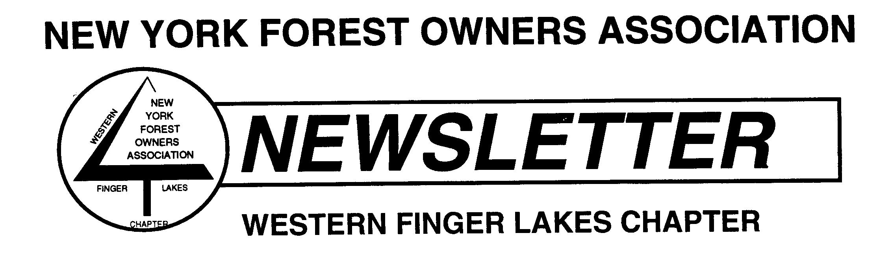

WFL Chapter Meetings and Coming Events

- WFL Chapter Board of Directors Meeting - The next WFL Chapter Board of Directors meeting will be held May 23rd and will start at 7:00 pm. The meeting will be held at the DEC A-frame in Avon at 6274 East Avon-Lima Road (Routes 5 & 20 – a few miles east of I-390).

- May 9, 2007 – WFL Chapter Meeting, Spring Program to be held at the United Church of Christ in Honeoye. The United Church of Christ is located just west of the only stop light on the north side of Route 20 A in Honeoye. The program Wild Turkey Biology, Life Cycle, and Habitat Needs will begin at 7:30 pm.

Wild Turkey Biology, Life Cycle, and Habitat Needs

Larry Becker NYFOA member and President of the NYS Chapter of the National Wild Turkey Federation (NWTF) will present a wild turkey overview. The goal of this presentation is to give the audience a brief overview about wild turkeys, and the NWTF’s private landowner conservation recognition program. The NWTF encourages good land stewardship through conservation and habitat improvement and maintenance, which can be accomplished while managing your woodlots and forests for profit. The majority of the presentation will cover wild turkey biology, life cycle, and habitat needs. Larry will also talk about safety for hunters and non-hunters who may be walking their woodlands during the turkey hunting season and conclude with some information about the NWTF and the organizations conservation efforts in NYS.

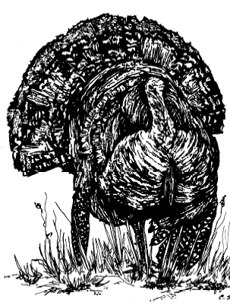
About Larry G. Becker - Larry is an avid conservationist, hunter and outdoorsman. As a volunteer member of the National Wild Turkey Federation (NWTF) he is currently the New York State Chapter President, Chairman of the NYS Chapter Wild Turkey Woodlands (WTW) Committee and a member of the NWTF’s Habitat Pro Staff. He is also a NYFOA member and a certified Master Forest Owner volunteer through the Cornell University Cooperative Extension program. Larry is the recipient on the NWTF’s WTW’s private landowner conservation Northeast Region award in 2002 and the overall National Award in 2003. Larry is a retired business consultant. He has dedicated many hours to not only the NWTF but to a number of other volunteer organizations over the years. Larry and his wife Carol currently live in Webster, NY. They also own a 116-acre farm in the township of Pike, Wyoming County, NY where Larry dedicates many hours towards improving habitat for wild turkey and deer. In addition to a Forest Stewardship plan, prepared by the NYS Department of Environmental Conservation (DEC), portions of the property have been enrolled in the USDA/NRCS FLEP and WHIP programs. The farm has also been used for the NWTF’s WTW’s habitat seminars for private landowners and by the local NRCS and County Soil & Water Department for conservation tours and demonstrations. Larry has incorporated the Forest Stewardship plan into a master plan for the property, which is reviewed and updated annually incorporating input form NRCS, County Soil & Water, NYS DEC forester, Cornell Cooperative Extension, and NWTF biologists. His son Todd recently purchased an adjacent 85 acres, a portion of which was already enrolled in the WHIP program. They both look forward to a comprehensive conservation plan to take advantage of the unique characteristics of both properties towards the goal of optimum wildlife habitat.

Interested in taking a Game of Logging Class, Let us know?

Last year our chapter sponsored three Game of Logging sessions, and all were well attended. We are currently debating whether there is sufficient interest in the chapter to offer the class again this year.

The Game of Logging is a nationally recognized training class in the safe and effective use of a chainsaw. The Level 1 class covers safe use of a chainsaw, safety equipment, sharpening, and basic tree felling techniques. It is suitable for people who have never used a saw as well as people who have some experience but no formal training. Everyone leaves this class with the experience of having cut down a tree. Level 2 deals with saw maintenance, additional felling techniques, and how to handle some hazardous situations such as spring poles. Level 3 gets into more technical aspects of tree felling, such as estimating tree height and techniques for working on steep hills.

The classes will be scheduled for the fall, probably in September or October. Each class would last a full weekend day, and would probably be held in Genesee, Livingston, or Ontario County. The cost is usually around $125. Last year the chapter paid half the registration cost for its members, and may be able to contribute again this year. Participants would bring their own chainsaw, safety equipment, and lunch.

I have taken Levels 1 and 2, and I have found them extremely helpful. I am much more safe and efficient when doing TSI work in my woodlot. I think anybody who uses a chainsaw, or plans to, will find these classes very helpful. Registration for a class would also make a good gift for somebody you know who uses a chainsaw. For other people’s reactions to the classes, see the March/April 2007 issue of The New York Forest Owner.

If you think you would be interested in taking a Game of Logging class, let us know. Expressing your interest doesn't commit you to signing up for the class, but will help us decide if there are enough people to justify holding any classes. Please call Dale Schaefer (585-367-2849) or send email to Mike Seager (seager_michael@yahoo.com). Tell us whether you are interested in Level 1, Level 2, Level 3, or some combination of them. We would like to hear from people in April or May so we have time to schedule a class later in the fall.

If we do offer these classes, we also need a place to hold them. A good place to hold the class has at least 25 moderate-sized trees (8-15 inch dbh) available to cut with fairly easy access from an area where participants can park their cars. Bonus points are awarded for venues having restroom facilities and a shelter to get out of the rain. If you have a woodlot marked for TSI cutting, hosting the Game of Logging can be an easy way to get some of the work done for you.

Announcements

‘Forester for a Day’ Thinning Workshop
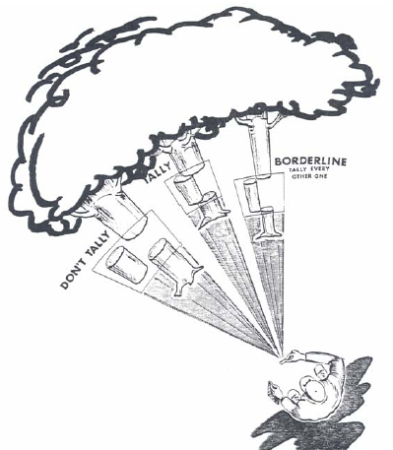
When: June 9th, 2007

Where: 3M Hunt Club (Joe Kilburys’) in Cohocton, NY

What: Foresters will provide basic instruction on stocking levels, basal area, inventory methods, use of a prism, thinning methods and decisions on what trees to leave or take. Instructors will include private forestry consultants Stanley Stek and Billy Morris as well as several foresters from the DEC. After the short instruction session, attendees will be divided into small groups to conduct an inventory, develop a thinning prescription and mark trees for removal. The marked trees will then be cut during lunch and the groups will return to the woodlot to see their handy work. During lunch, Billy Morris will talk about the forest management plan and the practices taking place on the hunt club property.

Details - Registration for this workshop will be limited to 25 people. Arrive around 9AM as the program will start at 9:30 sharp and go until mid-afternoon. This event is rain or shine so dress for the weather. The cost is $10. Make checks out to NYFOA. A simple lunch and morning refreshments will be provided. Register with Mark Gooding, DEC Forestry at 6274 East-Avon Lima Road, Avon, NY 14414. For more information call Mark at 585-226-5466.

Directions – from I-390 take exit 2 – Cohocton; go west on County Route 121; turn left on Lake Hollow Road; turn right onto Oil Well Hollow Road; down the road a ways the hunt club will be on your right. NYFOA signs will be placed along the way to guide you.
----------------------------------------------------------

Summer Woodswalk - In the Planning Stages

Summer Woodswalk in the Planning Stages- A recent change to New York’s tax laws has provided incentives for landowners to preserve their property through conservation easements. To show how conservation easements can work in concert with forest management to protect property from development while allowing for sustainable logging and other uses, we will have a woodswalk later this summer on the property of Carol Krebs. Carol and her late husband John partnered with the Finger Lakes Land Trust to develop a conservation easement on their property in Livingston County. They have also worked with a forester for many years to manage the property for timber production, wildlife habitat, and other values.

At this woodswalk we will hear from the Krebs’ forester about how the property has been managed over the years and how a timber harvest last fall fits into that management plan. We also hope to have a representative from the Land Trust discuss the conservation easement on the property and how it affects the forest management options.

The woodswalk will be late this summer, probably some time in August. Watch the next newsletter for a specific date, directions, and other details!
----------------------------------------------------------

ROPS RETROFIT REBATE

New York State Sponsored Tractor Rollover Protective Structure Program (ROPS) Retrofit Rebate.
Who: All New York farmers are eligible.
What: 70% of cost to retrofit up to $600. Limit one tractor per year, per farm. Roll-bars, ROPS awnings or cabs.
How: Call 1-877-ROPS_R4U (1-877-767-7748) for approval and assistance. They will help you find the right model and dealer, set up the appointment and file the papers.
The Program: The New York Center for Agricultural Medicine and Health (NYCAMH) (www.nycamh.com) has obtained funding from the NYS Senate Agriculture Committee (Senators Cathy Young and Jim Seward) to offer farmers partial reimbursement for the installation of ROPS on tractors that are currently unprotected. This effort is undertaken in partnership with the New York Farm Bureau, the Northeast Equipment Dealers Association and Farm Family Insurance. In this program’s first year, each farm may qualify for one rebate – until funds are expended.

How it Works:
- All participants must call the ROPS hotline for registration and pre-approval.
- NYCAMH hotline staff can research the type of equipment needed, advise the farmer on costs, assists with ordering of parts and coordination with dealers.
- Once the farmer receives an approval letter, the ROPS may be installed.
- The program can reimburse farmers for 70% of all expenses related to the ROPS installation up to a maximum of $600.
- Only one tractor per farm can be reimbursed during the initial year of this program.
- Upon submission of receipts for all expenses, a rebate will be sent to either the farmer or directly to the dealer.
- Expenses will be processed and checks issued within three weeks in nearly all cases.

The Facts:
- Each year 4 out of every 100,000 American workers, die on the job.
- For the American farmer, that number is 33 out of every 100,000.
- The fatality rate for farmers is 800% higher.
- The farm tractor is the leading cause of deaths.
- The leading causes of tractor deaths are side and rear overturns.
- Framers in the Northeast experience the highest rates of overturn deaths.
- Most of the deaths occur to farmers with many years of experience and many hours of tractor use.
- Deaths and serious injuries can be virtually entirely prevented with use of rollover protection and a seatbelt. More than half of New York tractors are unprotected.

Tractor ROPS: Tractor rollovers continue to be a major cause of death on small farms and with woodlot owners. Over 200 people die each year in tractor accidents that are not equipped with ROPS. Consider these facts provided by Dr. I. T. Hurtz, Cornell University farm safety program.

- ROPS, properly installed and used, practically eliminated tractor rollover deaths.
- Only 38% of tractors inspected in the 1990’s had ROPS, yet ROPS have been standard equipment on tractors build after 1985.
- All major tractor manufacturers have ROPS retrofit programs for most tractors built before 1985, yet 40% of tractor owners in New York are not interested in these programs even if offered for free.
If you use a tractor in the woods, pleas call 1-877-ROPS_R4U (1-877-767-7748) and retrofit it with ROPS. We need to keep all of our members safe and alive. (From brochure provided in the Allegheny Foothills Chapter newsletter)
----------------------------------------------------------

Emerald Ash Borer Advisory and Ash Germplasm Preservation Project
USDA NRCS New York Bulletin (No. NY190-07-02)

Purpose: To distribute information advising not to inadvertently import ash seedlings from quarantine areas when working with landowners and District Tree and Shrub Programs. To make available an opportunity to help conserve ash germplasm. Background: The Emerald Ash Borer, Agrilus planipennis Fairmaire, is an exotic wood boring beetle that was discovered in southeast Michigan in 2002. It attacks only ash trees Fraxinus spp. The larvae can kill mature ash trees—most of the ash canopy is killed within two years. The Emerald Ash Borer is blamed for the deaths of 25 million ash trees in Michigan, Ohio, Indiana, and Illinois. There is a USDA quarantine preventing transportation of ash seedlings and wood products from the states of Ohio, Indiana, Illinois, Michigan (below its Upper Peninsula), and Prince George County Maryland. The latter site was contaminated by a violation of the quarantine by a Michigan nursery. This notice is a warning not to import any ash species seedlings from the nurseries located in these quarantine areas. The nurseries are well advised about this situation and are legally liable if they do so. This is just an extra precaution. For more information on the biology and pictures on how to identify the Emerald Ash Borer and its symptoms on ash trees, go the APHIS website. http://www.aphis.usda.gov/ppq/ep/eab

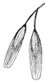
Ash Germplasm Preservation Project. In an effort to preserve ash germplasm, the Plant Materials Program has partnered with the National Center for Genetic Resources Preservation in Fort Collins, Colorado. The U.S. Forest Service has agreed to X-ray the collected ash seed to determine sound seed for storage. If ash tree populations are completely decimated by the ash borer, the stored seeds can be used as the genetic base for work to re-establish ash trees for future generations. The Plant Materials Program is seeking volunteers to collect seed from all species of ash trees throughout the U.S. in the growing regions of ash trees. Seeds may be collected from a single tree or from a population of similar trees. The collection needs to be identified to the exact species of ash with a minimum of 500 seeds per sample. This initiative could be of interest to local nature preserves and other partners. The collection form and instructions, tree and site identification, guide to determine seed quality and quantity for submission, and promotional materials are located at http://www.ashseed.org.
----------------------------------------------------------

New York State Department of Environmental Conservation

Stumpage Price Report Undergoes Changes

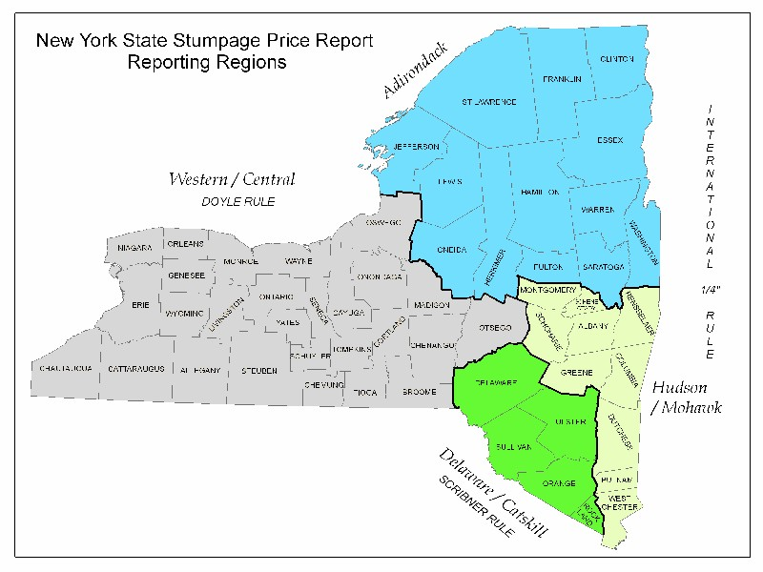
After many years, the Stumpage Price Report has undergone some changes in the way that reported prices are developed and presented. The source of the prices, various volunteer buyers and sellers of stumpage, and the method of collecting prices have not changed. Overview of Major Changes: Reduction in the number of price reporting areas from twelve to four. Recent analysis has shown, with only a few distinct exceptions, that the twelve previously indicated reporting areas are not necessarily distinct "market areas". Instead of continuing to indicate the location of questionable market areas, areas based on large, physiographic timber growing regions will be used. Now reporting the actual range of reported prices for each price category (Low, Average, and High) rather than a single price figure for each category. The median value for the reported range is also provided. This change provides the user with more information and better demonstrates the variability in timber prices. Reported prices that in the past would have served to develop prices in the previously reported small market areas will now be included in developing a range and median price in the new areas. For complete information visit: http://www.dec.state.ny.us/website/dlf/privland/utilization/stumpage.html
----------------------------------------------------------

Forest Tax Law Changes

On October 22, [2004] President Bush signed into law a far-reaching $136 billion corporate tax package that, among other things, helps forest landowners by reforming timber-taxes while closing tax loopholes and bringing U.S. exporters in line with international trade rules. One item in particular is of specific interest: the modification to Internal Revenue Code Section 631(b) that was over two decades in the making is now the law of the land. One CPA, who specializes in accounting for forest and forest products concerns, commented that, “whether they know it or not, the 631(b) fix may be the most important timber tax legislation that non-industrial private forest landowners will see in their lifetimes.”

Although, the Forest Landowners Tax Council has been the lead organization on the IRC Section 631(b) fix for years – having focused on the issue since its establishment in 1996 – the Association of Consulting Foresters was no small player in this Hill victory. ACF contributed to the Congressional Staff Seminars on forest taxation with FLTC that focused on resolving this issue. Also, a disproportionate number of the founders of FLTC were ACF members. And ACF members Mary Clapp (AR), Ely Frazer (GA), Keville Larson (AL), Bob McColly (PA), Harry Murphy (AL), Bill Siegel (LA), Ron Stuntzner (OR), Charlie Tarver (GA), Bret Vicary (ME) and others have contributed mightily to this effort, which has quietly caused so many problems for so many forest landowners in every region of the United States.

The 631(b) reform will allow non-industrial private forest landowners capital gains treatment on income from lump-sum stumpage sales, while maintaining their right to get capital gains on pay-as-cut sales. Senator Jeff Sessions of Alabama, and Congressman Mac Collins of Georgia, have been steadfast sponsors of 631(b) correcting language though four Congresses. Members Tarver and Siegel worked with the Joint Committee on Taxation to correctly calculate the measure’s cost to the U.S. Treasury as "negligible." Others worked to successfully add the language to the JCT’s Tax Simplification List (the only timber item on the JCT list), to have successfully encouraged the Land Trust Alliance, a high-profile environmental group, to write the Senate Finance Committee and the House Ways & Means Committee to request passage, to have successfully worked to have the U.S. House of Representatives pass the modification in every Congress since and including the 105th, and to have enlisted the support of numerous allied organizations in the effort including the Internal Revenue Service. The change is effective January 1, 2005.

Another timber-tax provision added by industry to the JOBS bill (aka: H.R. 4520, corporate tax bill, FSC/ETI bill) will allow all private forest landowners to expense up to $10,000 for reforestation costs in the year incurred with an amortization period of 84 months for the remaining costs (there is no ceiling on those costs!). However, a Forest Service economist has calculated that the change from a “Reforestation Tax Credit” approach – the old statutory language, which has been eliminated – to the new “Reforestation Expensing” approach will cost non-industrial private forest landowners about $800 at the $10,000-level of expense (this negative effect corrects itself at higher levels of reforestation expenses). And, as has been reported by FLTC for months, the expensing approach will not work for NIPF landowners who do not “materially participate” in the management of their forestland as defined under Passive Loss Rules, which were generated by an unintended consequence of securities legislation passed in 1986. This new law is effective immediately.

The “vehicular” corporate tax bill grew out of the need for Congress to respond to a World Trade Organization ruling that a $5 billion annual subsidy for U.S. exporters was illegal. As a result, 1,600 American exports to Europe are being hit by penalty tariffs that stood at 12 percent – at the time of the bill’s enactment – and rose by one percentage point a month until remediated. The bill became the vehicle for the most significant overhaul of corporate tax law in nearly two decades. (From the Association of Consulting Foresters, newsletter, November/December 2004. IRC Section 631(b) Reform & Reforestation Expensing Signed by President, By Frank Stewart ACF/RF, ACF Director of Government & External Affairs, Page 5, http://pro.magellangps.com/en/news/case_studies/ACFNewsletter.pdf)

Calendar of Other Events
-----------------------------------------
New York Nut Growers Association Meeting

April 21 - New York Nut Growers Association meeting: The spring meeting of the NY Nut Growers Association will be held at the Rogers Environmental Center in Sherburne, NY on Saturday, April 21, from 9:00 to 3:00. Roy Hopke, from the American Chestnut Foundation, will make a presentation about the American chestnut and the chinquapin. He will lead a tour of the Center's chestnut grove. Peter Haarmann, a grower from Long Island, will demonstrate successful tree planting with reusable transplant pots, and discuss his work with English walnut seeds from Europe and from the USDA Germplasm Repository in Davis, California. There will be an update on the NYNGA Hardy English Walnut Project. Richard Fahey will demonstrate grafting techniques for fruit and nut trees which he employs on his 100 acre homestead. The $15.00 cost of registration includes a light breakfast and lunch. Please mail a check made out to NYNGA to Tom Potts, 26 Willets Ave., Belmont, NY 14813. Include a phone number and e-mail address. Drop-ins are welcomed, too. If you have questions, call Tom at (585) 268 - 5588 or Jerry Henkin at (914) 423 - 7458.

Spring 2007 -Chainsaw Safety and Tree-Cutting Productivity Training
through Cornell University – ForestConnect

This training presents the Game of Logging program, re-designed for private forest owners, firewood cutters, and homeowners wishing to gain a more thorough knowledge and practical, hands-on experience with safety and productivity. No experience is required for Level I participants. Participants learn increasingly advanced techniques during Level I, II, and III for directional felling, safety, and saw and chain maintenance. Each level builds on skills from previous training levels, so advanced levels require participation in earlier levels. Registration includes hands-on training with a Game of Logging Certified Instructor, handouts, light refreshments, and a certificate of completion. Participants personally fell a tree under the guidance of a certified instructor. All sessions start at 7:30 AM and conclude at approximately 4:30 PM, though occasionally longer. Trainings are held regardless of weather so please dress accordingly. The program is offered at Cornell University's Arnot Forest in Van Etten, Schuyler County. Participants should meet at the south gate entrance.

Level I includes: Using and maintaining safety equipment, safety features of the saw, how to hold and handle a saw safely to reduce fatigue, understanding parts of a tooth for sharpening, understanding the reactive forces of a running chainsaw. We will learn the proper way to do a bore-cut. Participants learn the mechanics and physics of hinge wood, directional felling to a plan, and how to identify the lean in a tree.
- Level 1 offered three times: May 5, May 19 and May 21.

Level II includes: Saw maintenance to reduce downtime and improve the performance of your chainsaw,
Safe handling of spring poles, felling to a plan with more precision, introduction to limbing, and safe removal of hung trees.
- Level 2 offered May 6, May 20, and May 22.

Level III includes: use of the GOL "Pro-sight" tool to calculate tree height, understanding hinge length to control side lean, advanced felling and wedging techniques, limbing techniques for side hill and tension wood, trees will be felled against the natural lean. Some limitations in felling will be identified.
- Level 3 offered June 23.

Registration fees for NYFOA members are $132 per day and non-NYFOA members are $152 per day. Pre-registration and pre-payment are required. To register mail payment by check indicating the name of the event, dates of the event, and your contact information to DNR-CCE-GOL, 108 Fernow Hall, Cornell University, Ithaca, NY 14850. Registration is limited to 10 participants on a first-come, first-served basis. Minimum of 6 participants required. Directions will be provided with confirmation of registration. Overnight accommodations may be available at Arnot Forest for an additional fee. Participants should plan to bring their own chainsaw and personal protective equipment, including: hard hat, eye protection, hearing protection, and chaps. For information call 607 / 255 – 2115.

Rochester Regional Group of the Sierra Club - 9th Environmental Forum
Preservation of Hemlock/Canadice Lakes - Hemlock/Canadice: the Future of Our ‘Little’ Lakes

April 19 - Rochester Regional Group of the Sierra Club - 9th Environmental Forum- Rochester Regional Group To Hold Community Forum on Preservation of Hemlock/Canadice Lakes - Hemlock/Canadice: the Future of Our ‘Little’ Lakes 6:00pm - 9:30pm, Thursday, April 19th First Unitarian Church, 220 S. Winton Rd, Rochester, N.Y. [An event jointly sponsored by the First Unitarian Church Environmental Committee] http://newyork.sierraclub.org/rochester/outings.htm
Some Interesting and Maybe Helpful Websites

- eBird is a real-time, online checklist program, eBird has revolutionized the way that the birding community reports and accesses information about birds. Launched in 2002 by the Cornell Lab of Ornithology and National Audubon Society, eBird provides rich data sources for basic information on bird abundance and distribution at a variety of spatial and temporal scales. www.eBird.org
- New York Forest Link, Northern New York Pilot Project, Linking Forest Owners & Wood Products Customers. The New York Forest Link, connects private forest owners of Northern New York with forest products customers. A project of the New York Forest Owners Association (NYFOA), New York Forest Link helps generate markets for products from Northern New York's sustainably managed forests-from saw logs to wild ginseng. Whether you're a customer interested in purchasing high-quality regional forest products or a landowner wishing to market those products, this site will connect you with the people and information you need. http://www.nyforestlink.org/
- Forest Landowners Association, Inc. Their mission is to support, through advocacy, education, and information, forest landowners' responsible management of their private property. http://www.forestlandowners.com/
- Historic USGS Maps of New England & NY. The United States Geological Survey began its topographic atlas of the United States in 1882. The University of New Hampshire's Library's Government Documents Department holds a working collection of over 55,000 paper USGS maps. This online collection of over 1500 USGS topographic maps includes complete geographical coverage of New England and New York from the 1890s to 1950s. http://docs.unh.edu/nhtopos/nhtopos.htm

Agricultural energy

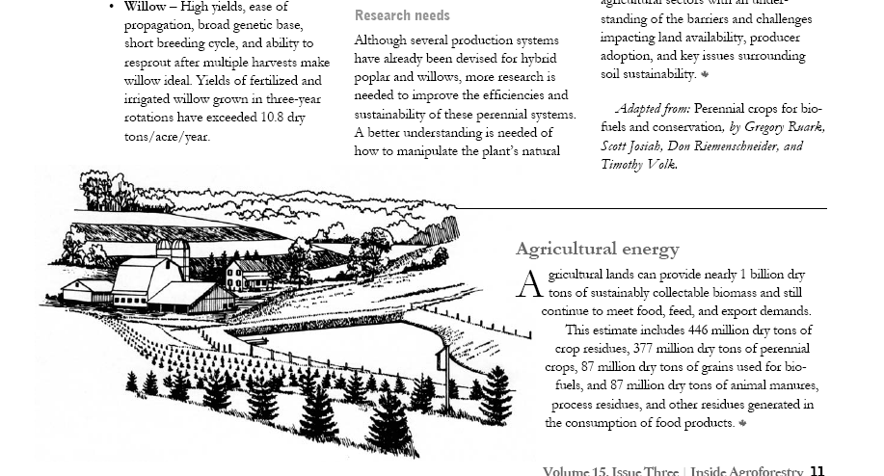
Agricultural energy -Agricultural lands can provide nearly 1 billion dry tons of sustainably collectable biomass and still continue to meet food, feed, and export demands. This estimate includes 446 million dry tons of crop residues, 377 million dry tons of perennial crops, 87 million dry tons of grains used for biofuels, and 87 million dry tons of animal manures, process residues, and there residues generated in the consumption of food products. (Volume 15, Issue Three, Inside Agroforestry page 11. Read the complete Inside Agroforestry story Fuel for the Future at http://www.unl.edu/nac/insideagroforestry/vol15issue3.pdf, and for additional information visit USDA National Agroforestry Center http://www.unl.edu/nac/index.htm)

Welcome New Members
W.H. Andersen | Bath |  | Marc & Becky Montgomery | Bergen
CMC Vineyards Inc | Dundee |  | Chris Nally | West Bloomfield
Timothy Grooms | Pavilion |  | James L. Richards | Lockport
Wayne Hermanson & Kate Bennett | Rochester |  | William R. Shaw | Trumansburg
Brian Kehoe | Auburn |  | Craig Stephens | Naples

Tree Tubes available from WFL

Contact Ron Reitz at 585-367-2847

Tree Tube Description |  | Member Price | Non-member Price
4’ without stakes |  | $3.00 | $3.50
5’ without stakes |  | $3.50 | $4.00
4’ with stakes |  | $3.50 | $4.00
5’ with stakes |  | $4.00 | $4.50
Also available – slightly used 4’ without stakes @ $1.75 apiece.



Richard Dennison Receives W.F.L Chapter Activity Award 2006

Dick joined the WFL Chapter of NYFOA in 1990 and soon became an active member by serving on the Board of Directors while learning to manage his woodlot. He has always volunteered at Empire Farm & Field Days in Seneca Falls, currently holds the position of Chapter Secretary, and has been managing the Video Library for many years. Dick was instrumental in planning and organizing our First Annual Chapter Dinner Meeting which was a great success with over 70 members in attendance. We can always count on Dick to do an outstanding job on whatever he commits his time and talents to. Thank you Dick for all of your volunteer efforts in the WFL Chapter and NYFOA!
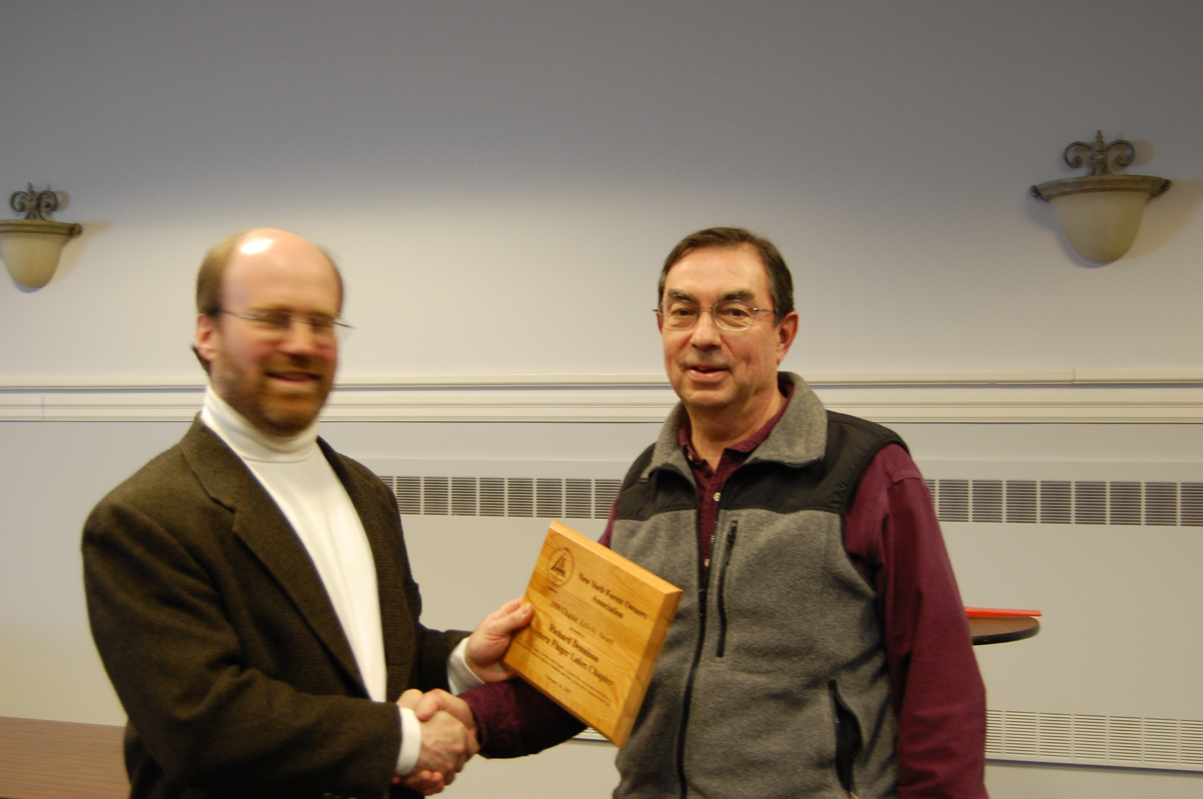

Note: NYFOA’s Chapter Activity Award thanks a volunteer individual or couple from each chapter for helping the Chapter to operate in reaching members and other private forest owner outreach in the area. The award was presented to Dick at the Annual State meeting during New York Farm Days in Syracuse.

Closing Comments
-------------------------------------------------------------
WFL Chapter Chair: Tony Ross announced that he is stepping down as Chair. Tony has been the Chair for the past two years. Dick Starr, our Vice Chair, will be taking over the duties of the Chair. We want to thank Tony for his service to the Chapter, as Chair, for the last two years.

Please consider donating your time and talents in assisting the WFL Chapter with its many activities. Any assistance you could give to the Chapter would be greatly appreciated.
Some current vacant positions and/or openings include:

*Outdoor Activities Coordinator
*Publicity Director
*Membership Director

Final Note: If you have a news item, announcements, stories, or any other information you would like to add to the Chapter Newsletter please send them to me. The next Newsletter will be out mid-July, so I would need the information by or before July 1st.

If you wish to submit a letter for entry into the newsletter, please send it to the Chairperson for consideration by the Board of Directors.
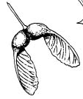
Faith in a Seed
“Though I do not believe that a plant will spring up where no seed has been, I have great faith in a seed. Convince me that you have a seed there, and I am prepared to expect wonders”
Henry David Thoreau

NEW YORK FOREST OWNERS ASSOCIATION
PO BOX 541
LIMA, NEW YORK 14485
NONPROFIT
ORGANIZATION
U.S. POSTAGE
PAID
Lima, NY
Permit No. 2

The NEW YORK FOREST OWNERS ASSOCIATION NEWSLETTER is published for members of the Western Finger Lakes Chapter of the New York Forest Owners Association (NYFOA) and is published 4-5 times per year. NYFOA was founded in 1963 and is organized to encourage the wise management of private woodland resources in New York State by promoting, protecting, representing and serving the interests of woodland owners. The Western Finger Lakes chapter was founded in 1988 and encompasses Genesee, Livingston, Monroe, Ontario, Orleans, Seneca, Steuben, Wayne, and Yates counties.

Membership is open to anyone interested in understanding how to manage a woodlot. NYFOA membership can bring returns in the satisfaction of growing quality timber, stabilizing forest industries and markets, providing permanent jobs, increasing the value of your woods, enlarging areas of natural beauty across the state, and leaving behind a monument in living trees to bless the tomorrows for the boys and girls of today. For information on becoming an NYFOA member, contact Liana Gooding, NYFOA Secretary, NYFOA, P.O. Box 541, Lima, NY, 14485 or at 1-800-836-3566. Annual membership is $30 for individuals and $35 for families and includes: subscriptions to this newsletter; to the bimonthly NYFOA state-wide publication, The New York FOREST OWNER; attendance at chapter meetings; and at two statewide meetings. Membership at the Contributing level ($50- $100) and Supporting level ($101 & up) are also offered. For more information visit www.nyfoa.org .

Readers are encouraged to submit articles for publication in the NEWSLETTER. Articles should be mailed or e-mailed to: Robert Remillard at the address below. Electronic submissions are preferred. Any letters should be sent to the Chair for consideration.

NYFOA WESTERN FINGER LAKES 2006 Board of Directors (terms run January - December, except Activity Directors are September - August):
Dick Dennison, Secretary
137 Wood Creek Drive
Pittsford, NY 14534
(585) 586-9098
Kibbycamp@rochester.rr.com

Harry Dieter, At-Large State Board Member
217 Rush-Mendon Town Line Rd
Honeoye Falls, NY 14472
(585) 533-2085
hadieter@frontiernet.net

Ray Cavallaro
245 Hurstborne Road
Rochester, NY 14609-5503
(585) 288-3411

Patrick Marren
NYSDEC
6274 E. Avon-Lima Road
Avon, NY, 14414
Walt Schuchardt
Video Librarian
20 Webster Road
Spencerport, NY 14559
(585) 352-4897

Mark Gooding
1834 Livingston St.
Lima, NY 14485
(585) 582-1862 H
(585) 226-5466 W
mcgoodin@gw.dec.state.ny.us

Robert Remillard
Newsletter
Lake Plains RC&D
446 West Avenue
Albion, NY 14411
(585) 589-5320 x112
Fax (585) 589-7709
Robert.remillard@ny.usda.gov

Mike Seager, Chapter Designated Director
P.O. Box 1281
Pittsford, NY 14534
(585) 414-6511
seager_michael@yahoo.com

Keith & Marianne Maynard, Program Director
4394 Buckelew Road
Bloomfield, NY 14469
(585) 229-4102
maynardkel@aol.com

Dale Schaefer
6017 County Road #37
Springwater, NY 14560
(585) 367-2849

Richard Starr, Chairperson
231 Farm View Dr.
Macedon, NY 14502
(585) 377-4849
pockaa@aol.com

Ron Reitz, Treasurer
6086 Canadice Hill Rd.
Springwater, NY 14560
(585) 367-2847
rrrlpr@aol.com

